LAB 14.1. 2403A51358, BATCH: 14

TASK 1: PORTFOLIO WEB DESIGN.

THE PROMPT: Design build a personal portfolio website to showcase your work. Requirements: • Create sections for About Me, Projects, and Contact.

o Suggest color palettes and typography. o Create a responsive layout with Grid/Flexbox. o Add smooth scrolling navigation.

OUTPUT:

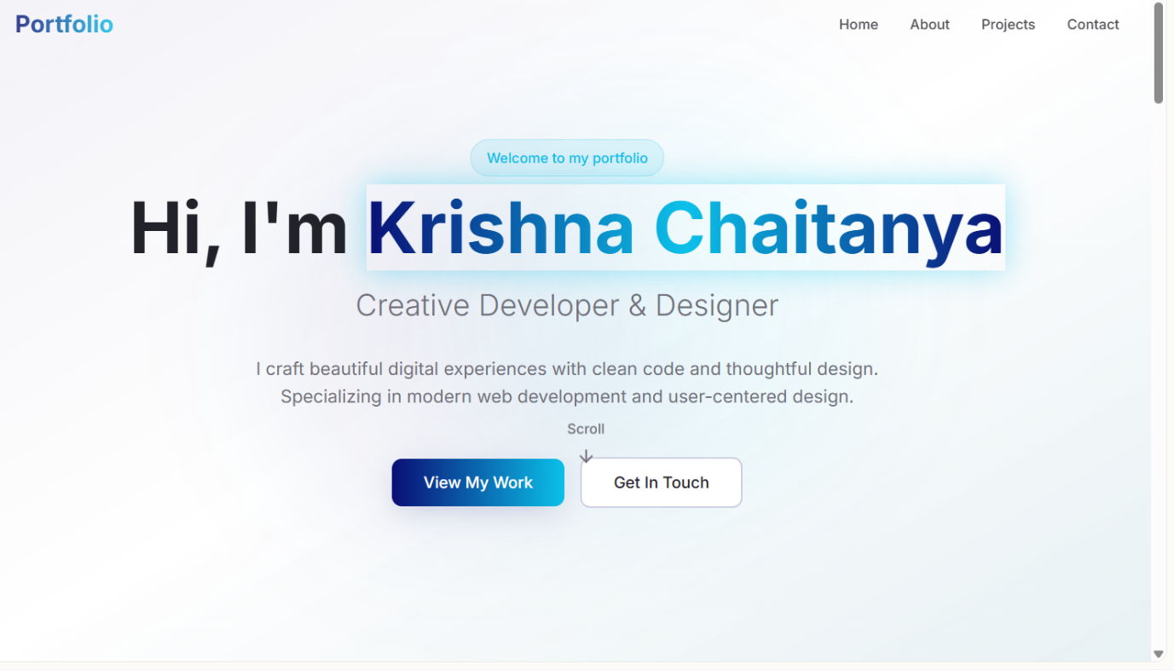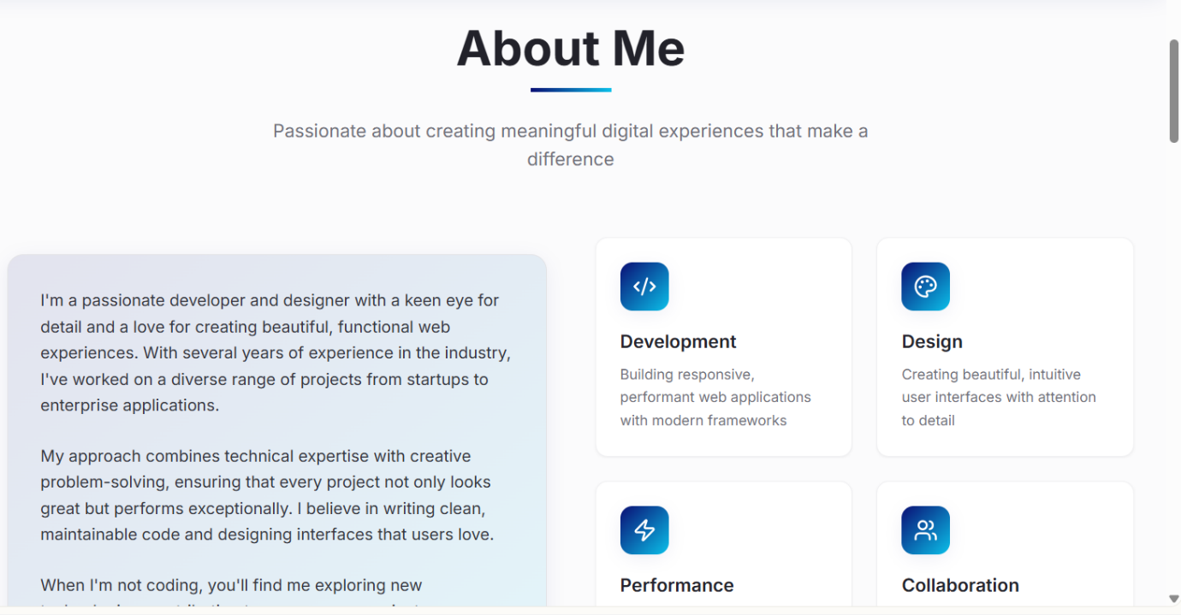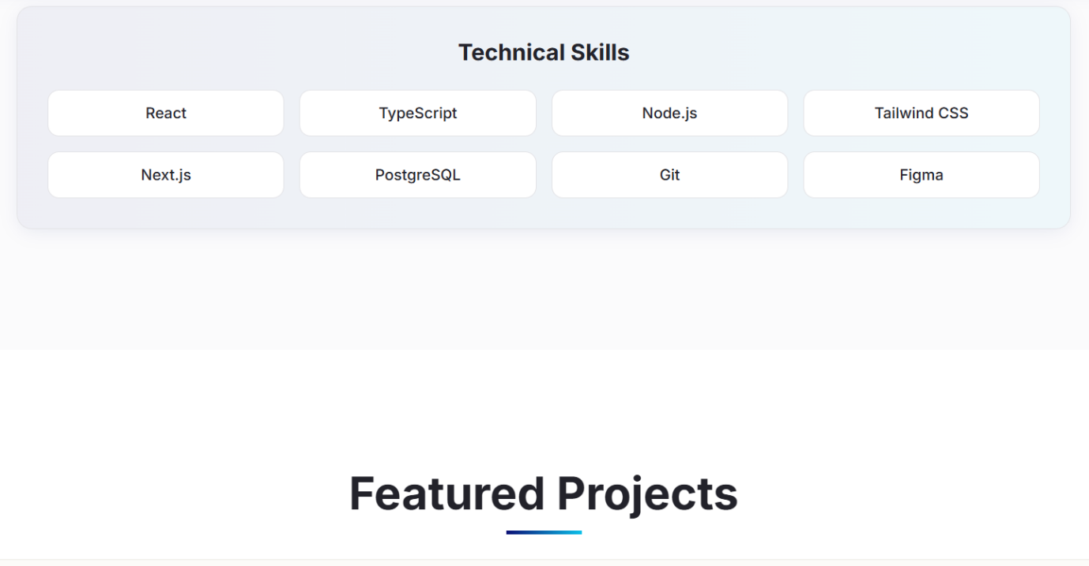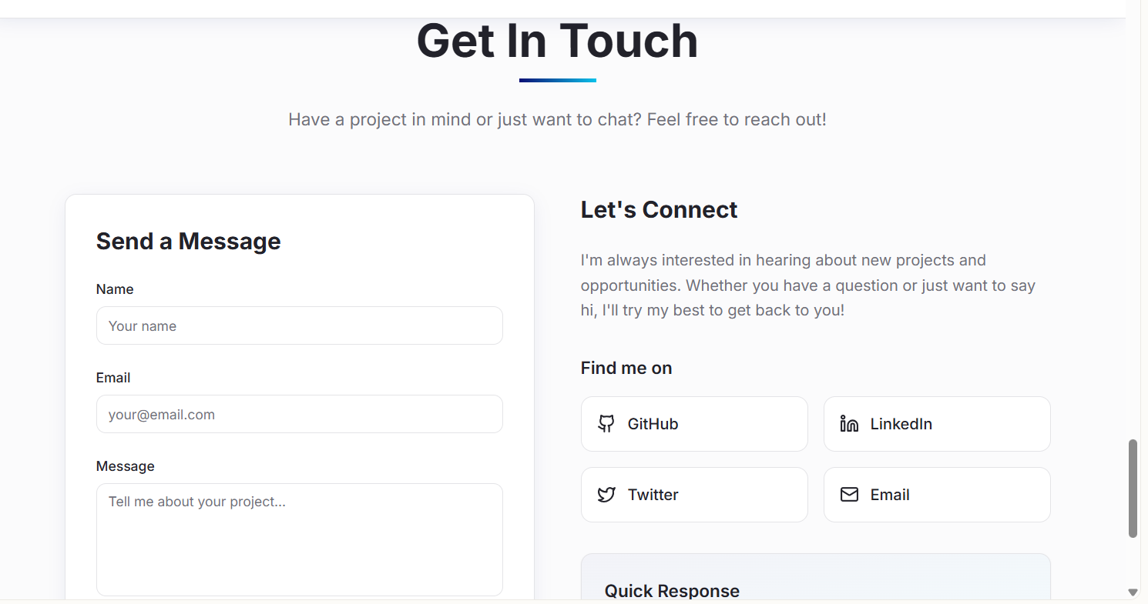

Observation : used lovable ai tool . lovable.ai is a website building platform

Task 2 – Online Store Product Page:

Prompt: Design a product display page for an online store. Requirements: • Display product image, title, price, and "Add to Cart" button. o Style with BEM methodology. o Make layout responsive. o Add hover effects and "Add to Cart" alert

Output:

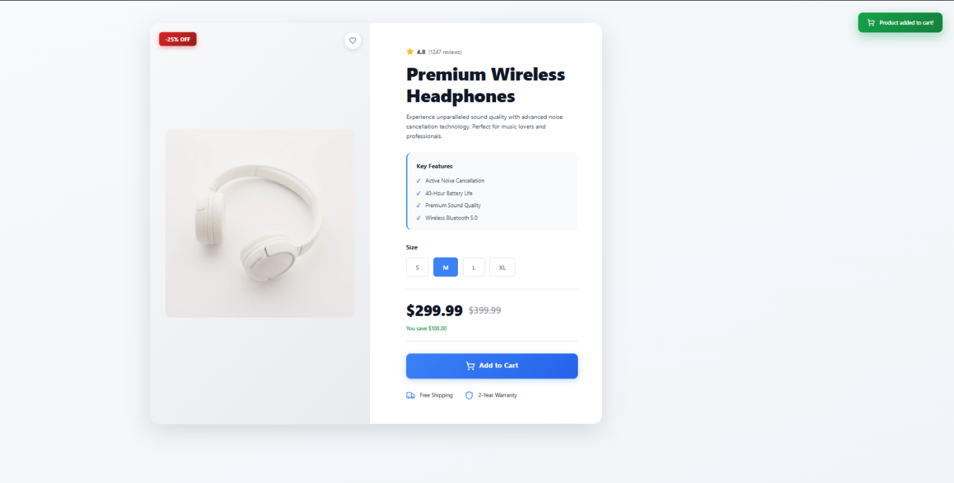

Observation: ive used bolt.ai to build this

Task 3: Event Registration Form

The prompt: Build an event registration form for a conference.  
Requirements:  
• Collect name, email, phone number, and session selection.  
• Use AI to:  
o Add form validation with JavaScript.  
o Make the form accessible with labels and ARIA.  
o Style with a professional look.

Output:

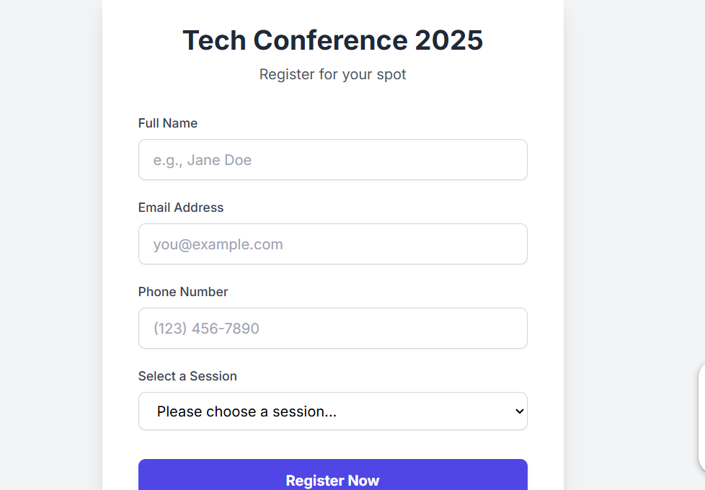

Task 4: (Data – Fetch API & Render List with  
Loading/Error States)

The prompt:

Write a complete JavaScript program that uses the fetch() API to get JSON data from a sample API (like https://jsonplaceholder.typicode.com/posts). The program should: Show a “Loading…” text or skeleton while fetching. Display a list of items (like post titles) once data loads successfully. Handle and display an error message if the fetch fails. Create all DOM nodes safely using document.createElement() (no innerHTML). Add simple CSS for loading and error states. Include helpful comments explaining each step. Output the full working HTML, CSS, and JS in one file so I can run it directly in the browser.

Output:

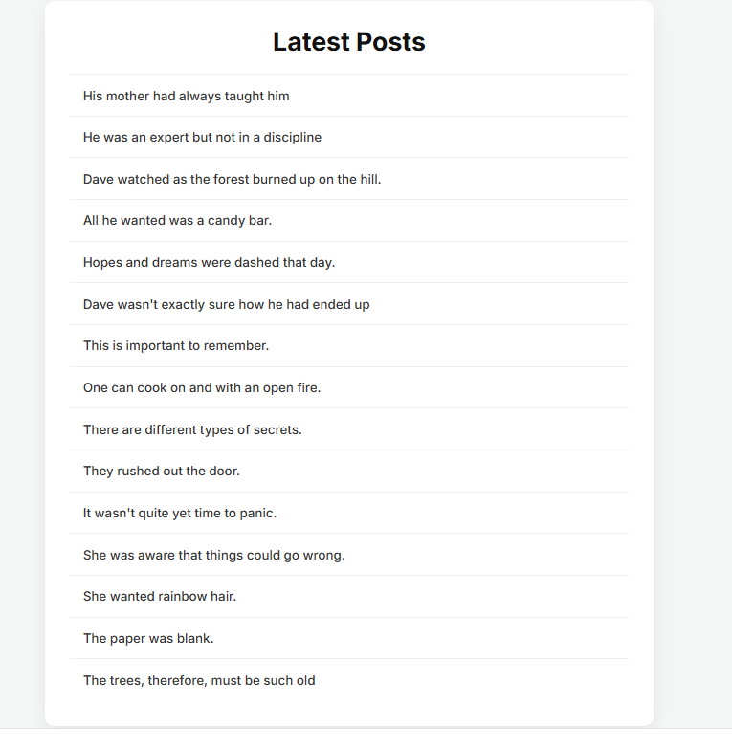Observation : I have asked the prompt in the geminiai pro . and it fetched the url and gave the points